**Assignment 6:**

Documenting Solution Requirements

|  |  |
| --- | --- |
| Name | Vignesh Ramasubramanian |
| Student # | 8857425 |
| Course | INFO8885 – Requirements Elicitation |
| Section | 4 |
| Professor | Shiv Bhuchar |
| Due Date | August 13, 2023 |

Table of Contents

Project Scope 2

Functional Requirements 2

Video Progress Memory and Easy Access [VPM] 2

Background Audio Playback [BAP] 4

Mini-Screen Mode [MSM] 6

Nonfunctional Requirements 8

[Usability] 8

[Performance] 8

# Project Scope

The solution we are developing for our client is a thorough improvement to the YouTube app that focuses on three main aspects to improve the user experience significantly. The first feature will allow the app to remember a user's progress in a movie, delivering subtitles and summaries of prior portions while moving to other applications or answering phone calls. Furthermore, the most recent incomplete video will be presented on the initial screen for fast access to current videos, assuring viewers like Raghul can quickly resume viewing from where they left off without manual searching.

The second feature would allow users to listen to audio from YouTube videos while using other programs in the background, allowing for effective multitasking, such as listening to podcasts or music while reading emails or other productivity tools. The music playback will continue even if the phone is locked or another app is started, and playback controls will be accessible from the notification panel and lock screen.

The third feature is a mini-screen mode for the YouTube app, which allows users to condense the video into a small, moveable viewing screen that runs in one corner of their smartphone's display. This mini-screen mode will feature configurable size, location, and transparency, allowing users to continue viewing videos while navigating between programs or doing other tasks.

This project aims to provide a smooth and enhanced watching experience while responding to the different demands of users and improving overall user satisfaction with the YouTube app.

# Functional Requirements

## Video Progress Memory and Easy Access [VPM]

The purpose of this feature is to enhance the YouTube app by allowing users to seamlessly resume where they left off in a video after switching to other applications or answering phone calls. The most recent incomplete video is also shown on the initial screen for quick access to continue watching. (The Word “System” in the requirement section refers to the YouTube mobile application)

|  |  |
| --- | --- |
| ID | Requirement |
| VPM-01 | When a user pauses or exits a video, the system shall save the timestamp of the last viewed position. |
| VPM-02 | The system shall display a "Resume Watching" section on the home screen containing the most recent unfinished video. |
| VPM-03 | The system shall offer an option to clear saved video progress data for individual videos in the user's history section. |
| VPM-04 | When a user initiates video playback, the system shall prompt the user to resume from the saved timestamp or start from the beginning. |
| VPM-05 | The system shall ensure a smooth transition and buffer-free resumption of videos after app switching. |
| VPM-06 | The system shall store video metadata, including captions and descriptions, to aid in context recall. |
| VPM-07 | The system shall securely manage user-specific video progress data to maintain privacy. |

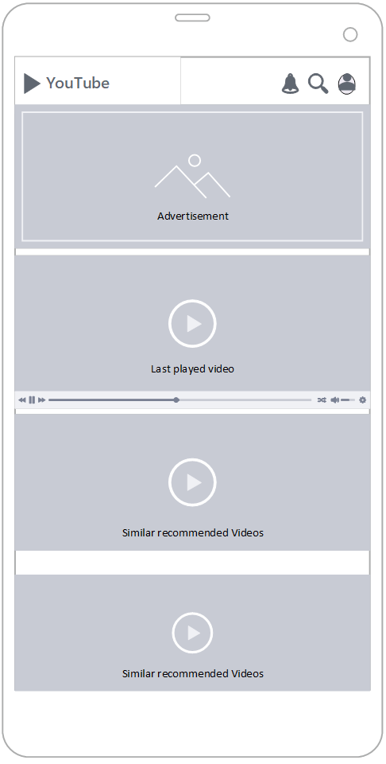

## Background Audio Playback [BAP]

The purpose of this feature is to allow users to multitask more effectively by enabling them to listen to audio from YouTube videos while using other programs in the background. (Word “System” in the requirement section refers to the YouTube mobile application)

|  |  |
| --- | --- |
| ID | Requirement |
| BAP-01 | The system shall enable audio playback for YouTube videos even when the app is in the background. |
| BAP-02 | The system shall provide a persistent notification with playback controls for background audio. |
| BAP-03 | The system shall ensure a seamless transition between different videos during background audio playback. |
| BAP-04 | When a user adjusts the playback speed, the system shall reflect the new speed for background audio. |
| BAP-05 | The system shall store the identifier and timestamp of the last played video for background audio. |
| BAP-06 | The system shall continue audio playback even when the device is locked or on the lock screen. |
| BAP-07 | The system shall maintain audio playback consistency across different device states. |
| BAP-08 | The system shall include an option in the settings menu to enable or disable background audio playback. |
| BAP-09 | If the user clicks the full-view button, then the system shall ensure a smooth transition from background audio to full video playback. |

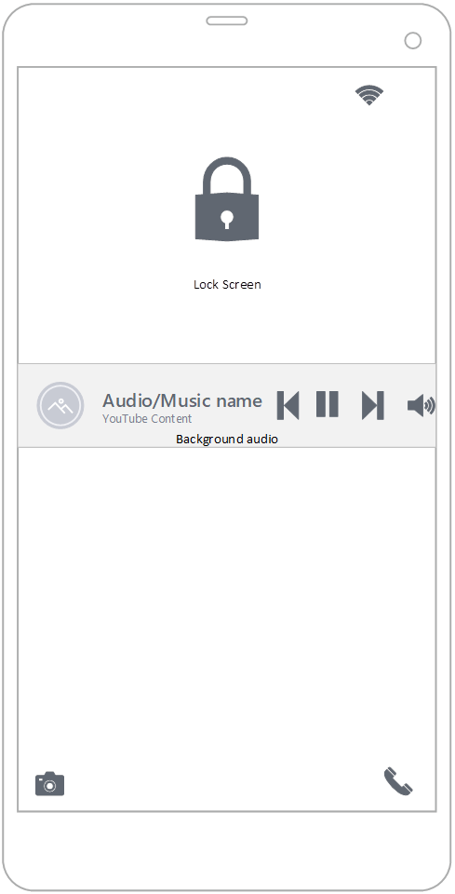

## Mini-Screen Mode [MSM]

The purpose of this feature is to lets users continue watching videos while navigating between different apps or performing other tasks on their smartphones by displaying videos on a small, resizable screen that floats above other apps. (Word “System” in the requirement section refers to the YouTube mobile application)

|  |  |
| --- | --- |
| ID | Requirement |
| MSM-01 | The system shall provide a button/icon with a Mini-screen symbol to enable the Mini-Screen Mode during video playback. |
| MSM-02 | The system shall allow users to adjust the size and position of the Mini-Screen Mode window using touch gestures. |
| MSM-03 | The system shall offer options in the settings menu to control the transparency level of the Mini-Screen Mode window. |
| MSM-04 | When users are in Mini-Screen Mode, the system shall display basic playback controls (play, pause, skip) within the window. |
| MSM-05 | The system shall support rotation gestures for switching between portrait and landscape orientations in Mini-Screen Mode. |
| MSM-06 | The system shall provide a button/icon within the Mini-Screen Mode window to expand to a full-screen view. |
| MSM-07 | The system shall maintain Mini-Screen Mode's responsiveness and stability during multitasking scenarios. |
| MSM-08 | The system shall maintain video audio continuity when switching between Mini-Screen Mode and full-screen mode. |
| MSM-09 | The system shall ensure Mini-Screen Mode remains above other apps and is draggable across the screen. |

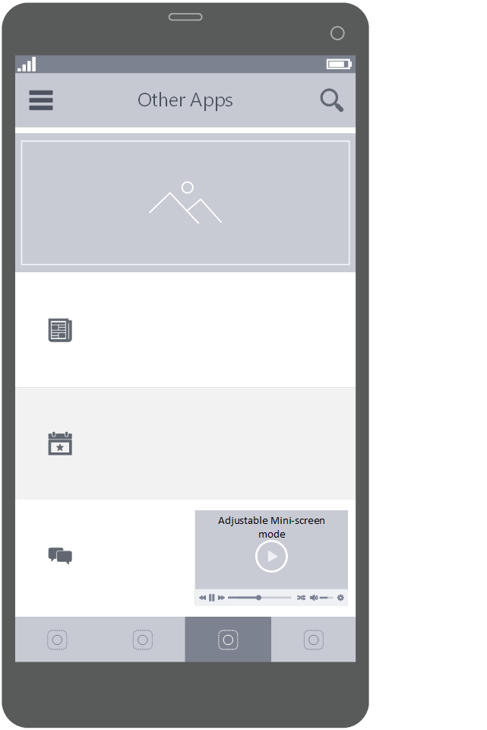

# Nonfunctional Requirements

## [Usability]

|  |  |
| --- | --- |
| ID | Requirement |
| USE-01 | The system shall provide a user-friendly interface, ensuring that most new users can start using the video progress memory feature effectively within 3 minutes of interaction. |
| USE-02 | When a user initiates playback resumption from the last viewed position, the system shall achieve a success rate of at least 95% in accurately returning the user to the intended playback point. |
| USE-03 | The system shall ensure that the video progress memory feature is accessible and operable for users with varying levels of digital literacy, with a success rate of at least 90% in performing basic actions within the first session. |

## [Performance]

|  |  |
| --- | --- |
| ID | Requirement |
| PER-01 | The system shall handle concurrent user interactions, such as playback control and app switching, without a detectable delay, achieving an input-response latency of fewer than 150 milliseconds. |
| PER-02 | The system shall respond to user input for video resumption, playback initiation, and playback controls within 1 second, achieving an average response time of 700 milliseconds or less. |
| PER-03 | During app-switching scenarios, the system shall ensure that video playback resumes seamlessly and buffer-free, with no more than 1% of playback instances experiencing interruptions or delays. |